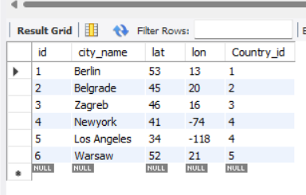

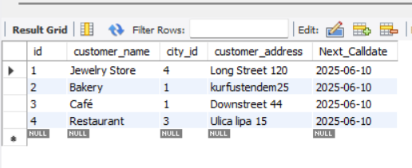

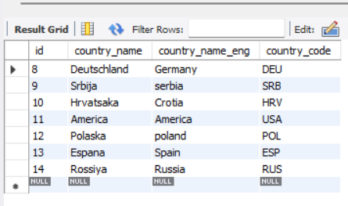

**Query:-**

**create database Assessql;**

**use assessql;**

**create table city(id integer primary key auto_increment,**

**city_name text,**

**lat integer,**

**lon integer,**

**Country_id integer);**

**insert into city(city_name,lat,lon,Country_id)values**

**("Berlin",52.520008,13.404954,1),**

**("Belgrade",44.787197,20.457273,2),**

**("Zagreb",45.815389,15.966568,3),**

**("Newyork",40.73061,-73.935242,4),**

**("Los Angeles",34.052235,-118.243683,4),**

**("Warsaw",52.237049,21.017532,5);**

**select *from city;**

**create table customer(id integer primary key auto_increment,**

**customer_name varchar(20),**

**city_id int,**

**customer_address varchar(20),**

**Next_Calldate date);**

**insert into customer(customer_name,city_id,customer_address,Next_Calldate)values**

**("Jewelry Store",4,"Long Street 120",now()),**

**("Bakery",1,"kurfustendem25",now()),**

**("Café",1,"Downstreet 44",now()),**

**("Restaurant",3,"Ulica lipa 15",now());**

**select *from customer;**

**create table country(id integer primary key auto_increment,**

**country_name varchar(20),**

**country_name_eng varchar(20),**

**country_code varchar(15));**

**insert into country(country_name,country_name_eng,country_code)values**

**("Deutschland","Germany","DEU"),**

**("Srbija","serbia","SRB"),**

**("Hrvatsaka","Crotia","HRV"),**

**("America","America","USA"),**

**("Polaska","poland","POL"),**

**("Espana","Spain","ESP"),**

**("Rossiya","Russia","RUS");**

**Select * from country;**

**Task:-1 List all Countries and customers related to these countries.**

**Query: -** **select country.country_name,city.city_name,customer.customer_name from country country left join city city on country.id=city.Country_id**

**left join customer customer on city.id=customer.city_id;**

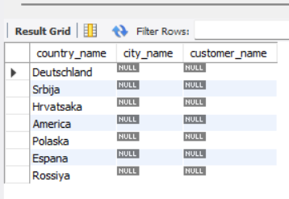

**Task : 2 (join multiple tables using both left and inner join)**

**Query: - SELECT**

**co.country_name_eng AS country,**

**ci.city_name AS city,**

**cu.customer_name AS customer**

**FROM country co**

**INNER JOIN city ci ON co.id = ci.country_id**

**LEFT JOIN customer cu ON ci.id = cu.city_id**

**ORDER BY co.country_name_eng, ci.city_name, cu.customer_name;**

